Glossary – for skin descriptors in relation to the PLACED tool only
Blister - water filled pocket of fluid between the epidermal and dermal skin layer
Dermatitis – (inflamed skin) the skin’s reaction to an irritant. The degree of the pathological response determines whether it is a contact or allergic dermatitis. Irritant contact dermatitis typically presents as a well defined erythema, which can be oedematous, itch and occasionally blisters. Necrosis can occur in severe cases and a secondary infection may be present.
Contact Irritants include; faeces/urine/product ingredients/chemicals
Dermis - the layer of skin beneath the epidermis which bleeds if damaged
Epidermis – outer layer of the skin, no bleeding if damaged
Erythema – skin appearance is red in colour due to increased blood flow causing vaso-dilation within stratum corneum of epidermis which causes heat - the epidermis is intact
Blanching erythema (redness) - When light pressure applied for 10 seconds and on removal the skin tone returns to normal
Non blanching erythema - When light pressure applied for 10 seconds and on removal the skin tone does not immediately return to normal as no capillary refill
Excoriation (peristomal) – ill defined loss of the peristomal epidermis due to persistent irritation, typically from urine /faeces with a bright red appearance and bleeding if it includes the dermis.
Hyperpigmentation – darkening of the skin due to excess melanin deposits in the skin
Hypodermis – layer below the dermis which consists largely of fat
Intact – no evidence of skin damage
Macerated - soggy unbroken peristomal skin often appearing wrinkled/uneven in appearance. To touch often feels wet and or spongy. Occurs as a result of extended exposure to excessive moisture usually from an external source. May be white/grey in colour if extended exposure to urine
MCJ – Muco-cutaneous junction - the area between the skin and bowel which has been sutured. A break down in the wound healing process will cause separation of the MCJ referred to as muco-cutaneous separation (MCS)
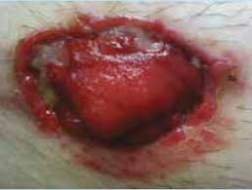
Oedema – excess fluid that builds up within the tissues under the dermal layer of the skin that results in a puffy swollen appearance (water logged)
Over-granulation - is an excess mass of new capillaries, fibroblasts and inflammatory cells in the healing process
Papule - is a raised area of skin tissue that's less than 1 cm around, can have distinct or indistinct borders. It can appear in a variety or shapes, colour and size eg wart, over granulation
Parastomal – Within or beyond adhesive area but NOT originated from muco-cutaneous (MCJ) and usually relates to product/underlying skin conditions/disease
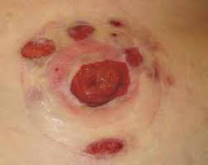
Peristomal – Beginning on or at the muco-cutaneous (MCJ) and involves the immediate surrounding skin of the stoma and can extend out to the periphery of the appliance
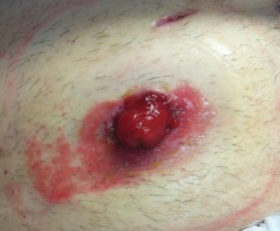
Pitting - an indentation which is left in oedematous skin after removing a source of pressure.
Plaque - An area of one or more lesions with the same appearance – it is usually an elevated, solid, superficial lesion that is typically more than 1 cm in diameter and associated with a number of skin conditions e.g psoriasis/eczema
Rash - a sporadic or insular change in skin colour or texture as a result of skin inflammation (dermatitis).It may contain flat or raised areas (papule).
Skin stripping – often referred to as PMARSI (parastomal medical adhesive related skin injury). This is mechanical trauma related to the removal of an adhesive flange (baseplate) skin barrier causing damage to the epidermis.
Skin tear - the skin appears ‘ripped’ or sheared with separation of skin layers. There may be partial or total skin flap loss, usually as a result of friction or trauma.
Subcutaneous skin layer – see hypodermis
Translucence – very thin skin which allows visibility of veins for example around a large parastomal hernia where skin is stretched and tight
Turgid - the flexibility of the skin is compromised due to chronic over hydration in the stratum cornea which leads to inflammation and loss of elasticity which feels firm to touch.
Ulceration - loss of the layers of the epidermis and / or dermis and can extend into the underlying tissue. In view of the uniqueness of peristomal ulceration this has been defined as;
- Class 1 – At risk of ulceration developing - Appearance – see non blanching erythema
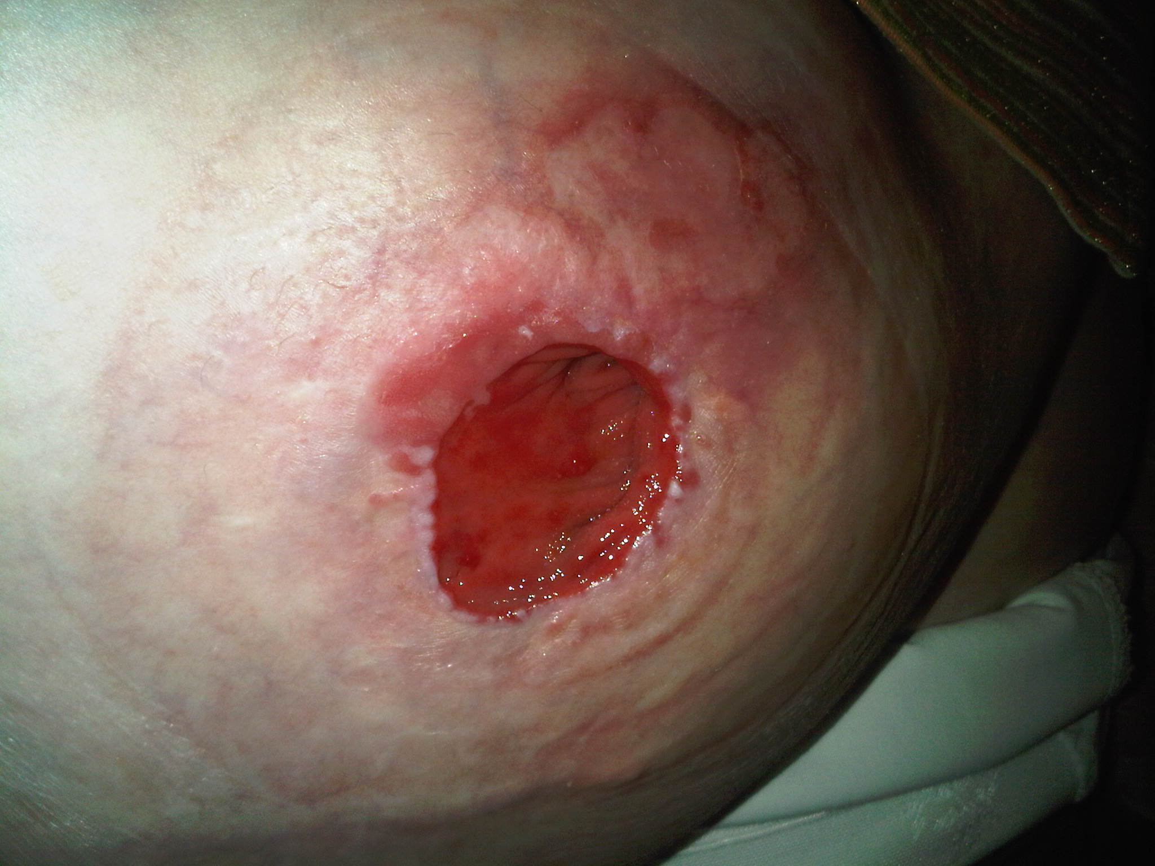

- Class 2 - Peristomal Ulceration - Appearance - epidermis broken red, wet , painful , bleeding
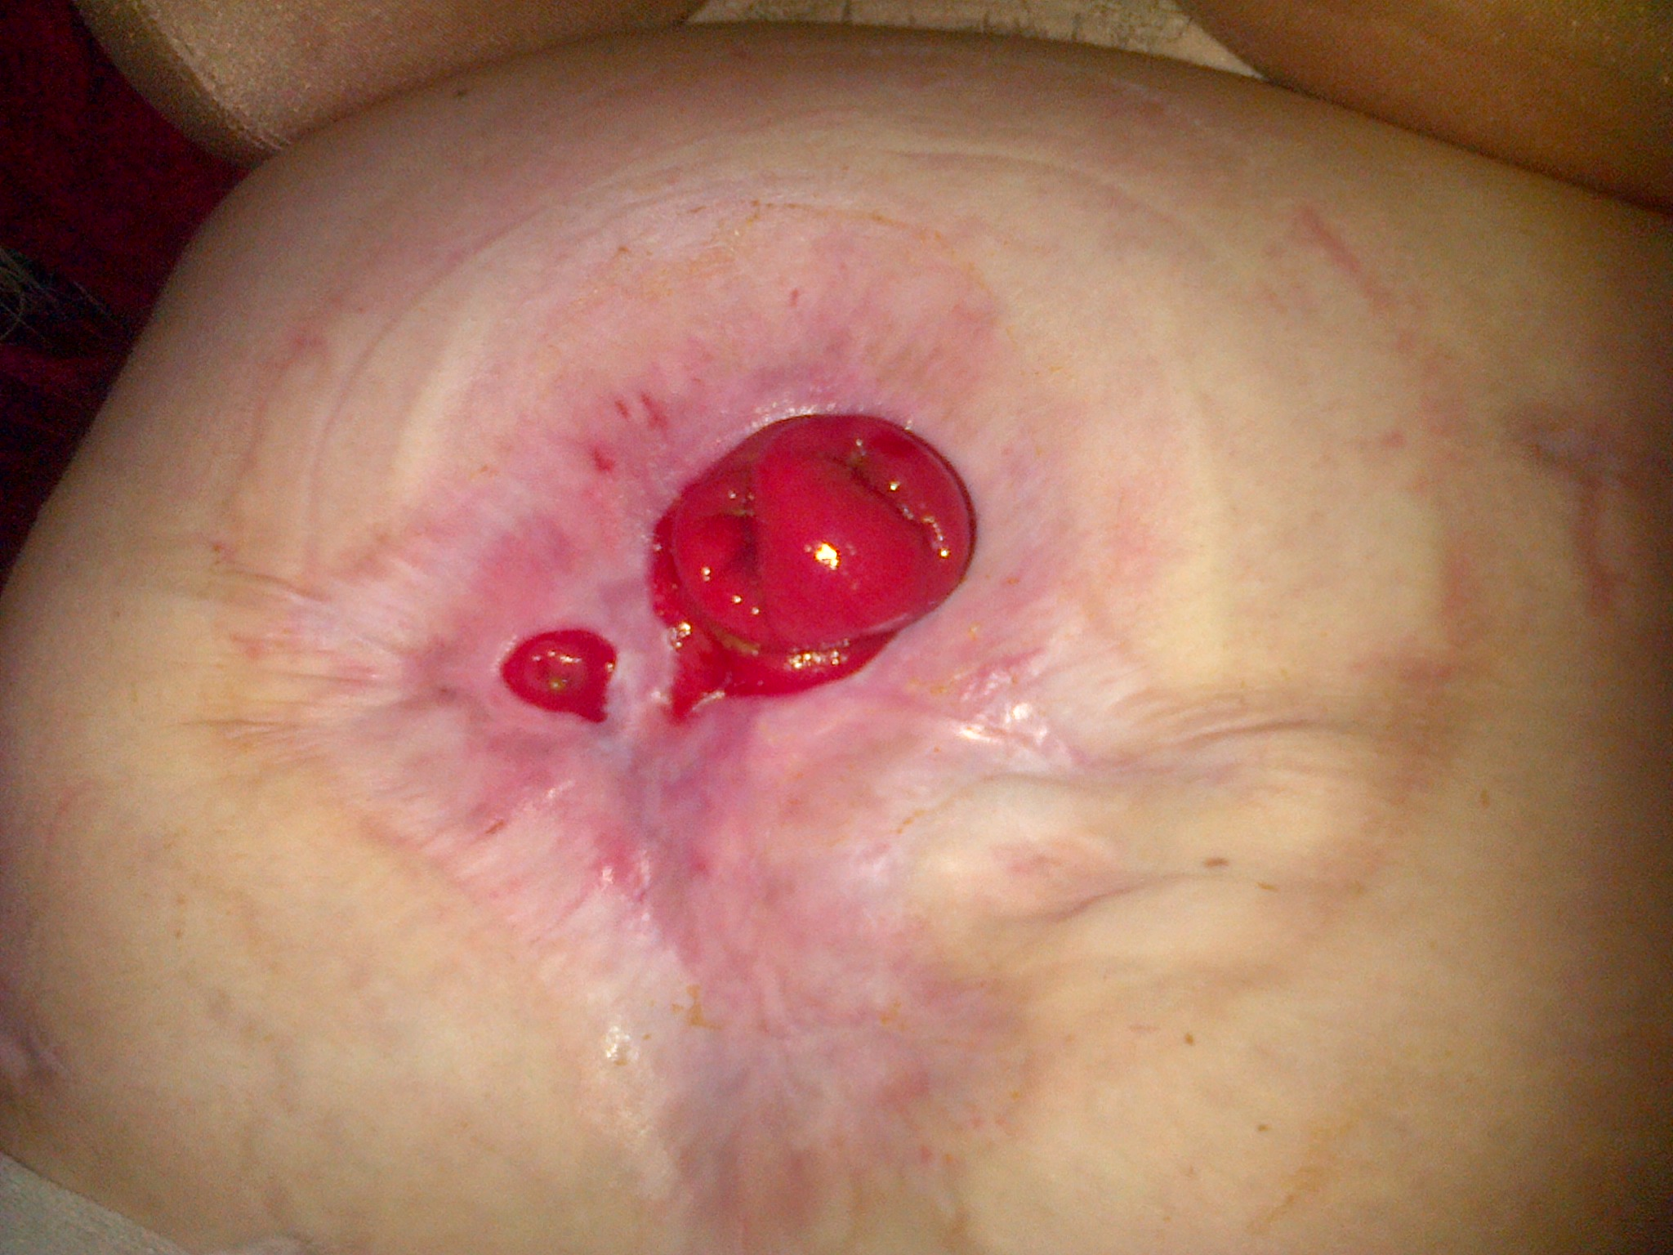

- Class 3 - Peristomal Ulceration – Appearance - damage to dermal layer and into subcutaneous layer; pain not constant
- 